**Phase 2 - Appraisal Application**

**DOMAIN:**

The application is an INTRANET application.

**Objective:**

The objective of the project is to develop an Appraisal application which facilitates the process of appraisal in an organization.

**Key outcomes:**

A multi-user application which can be used by HR, Manager and Employee of an organization. The HR can log in and setup an appraisal application which will be filled by manager and then by employee. The employee whose appraisal is pending will be notified to the HR and then the HR would initiate the appraisal process for that employee. Then the application will be forwarded and notified to the corresponding employee’s manager. Then manager would register his comments about the employee’s performance, competency and leadership skills. Then the application will be forwarded to the employee and after the employee’s inputs the form will be submitted.

**REQUIREMENTS:**

**FUNCTIONAL REQUIREMENTS:**

The login page should allow all types of people (HR, Manager and Employee) to login and the UI should be differentiated for different users. The HR can only create goals whereas Manager and Employee should be only able to fill the details about the goals created by the HR. HR and Manager should be notified about the new appraisal added which should be displayed through a log.

**NON-FUNCTIONAL REQUIREMENTS:**

The application should ensure agility and security across all layers when and where required. The quality analysis is to be done by providing different loads on the application. The loads can be differed by making changes in the above layers.

**PLAN:**

The planning depends on several factors. Some of them are discussed below.

**TIME:**

The application is planned to be released on 30th December 2019.

**PROCESS FLOW:**

The application starts with HR being notified about appraisal of an employee 2 weeks before completion of one year from the employee’s joining date or previous appraisal. An appraisal log should display pending and completed appraisals. The pending appraisals should be linked to a form which enables HR to add, edit or remove goals related to performance, competency and leadership skills. The form submitted by HR should be notified to the manager. The manager should submit his ratings and comments for the goals set by HR. Manager should be able to edit his entries. And after the manager submits the form it gets forwarded to the employee and the employee fills the details and submits the form.

**DESIGN:**

**HIGH LEVEL DESIGN:**

High level design documents like Data models for the application must be developed. Flowcharts, Wireframe explaining the process will be developed.

**LOW LEVEL DESIGN:**

LLD documents detailing the HLD like class, object diagrams can be added.

**This phase is planned to be finished in 2 days.**

**DEVELOPMENT:**

**APPLICATION ARCHITECTURE:**

The application development can be divided into 5 layers:

1. Client
2. Presentation
3. Business Logic
4. Data Access Layer
5. DATA

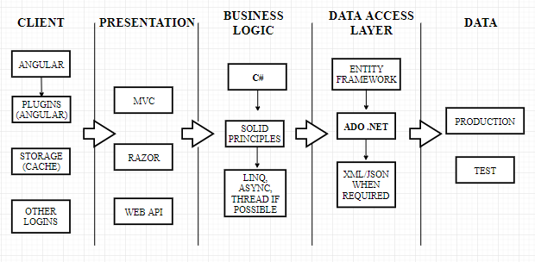

The client layer focuses on User Interface and User Experience. Angular JS framework is to be used for enhancing UI. Angular JS allows you to use plugins which injects built-in features into the application. The framework should also store data and deal with cache since some data is stored in cache and other data must be directed to database. The framework should give session tokens to a user and provide facility for logging in through Facebook, Mail account and OTP. The login page, appraisal log and appraisal form should follow a theme which is done through Angular JS.

The presentation layer gives idea about patterns that can be used in the application like MVC, Razor pages, Web APIs. Razor pages can be used to give suggestions (drag and drop) for the HR to set goals.

The business logic layer describes how the logic flows through the code. C# programming language helps us to design the application. The Designing should follow SOLID principles. The programming language can use LINQ, ASYNC operations, threads and tasks wherever needed.

The data access layer is where the entity framework which accesses the database is decided. ADO .NET must be used for a feature. Data must be stored in database or in XML/JSON depending upon the requirement from that data.

The DATA layer is where the actual layer exists. There are two types of data such as TEST data and PRODUCTION data. Test data is for testing the application and product data is the actual production data after the release.

This application must be integrated with Master data set application through APIs.

**This development phase is planned to be finished in 6-7 days.**

**TESTING:**

The test data is for Unit Testing and Integration Testing. Functionality, Compatibility, Performance, Database Integration, Security will be tested. **The testing phase is planned to be finished in 2 days.**

The rework after review, testing, checking and discussions would take 2 days.

**DEPLOYMENT:**

The release date for the application is 30 December 2019.

